

**St. Colmcille's Primary School**

Cullybackey Road

Ballymena

Co. Antrim

BT43 5DW

Tel. 028 25639970

info@stcolmcilles.com

[www.st.colmcilles.com](http://www.st.colmcilles.com)

23rd August 2020

Dear Parents,

**School Reopening Update**

**School Reopens!**

Last week we had the first test events of our New School Day procedures. The Year 7s have settled quickly back into school life and worked hard all week, it was like they had never been away. It was also fantastic to welcome our latest cohort of Year 1 pupils and parents for their Induction mornings. The efforts that parents and pupils have made to conform to the guidelines are greatly appreciated. I would also like to put on record my thanks to all the school staff who have worked tirelessly to enable us to reopen the school so smoothly on 17th August.

**Staffing Update**

I am delighted to announce that the Board of Governors have appointed Mrs McAleer as the vice-principal of St. Colmcille’s for the 2020-21 academic year. Mrs McAleer is extremely dedicated to the St. Colmcille’s community and her experience and leadership skills will help guide us through these uncertain times.

**Nurture Week: 24th - 28th August**

Years 1-6 will return to school this week for two familiarisation mornings. The classes have been split in half for these sessions to give the children a chance to become accustomed to their new surroundings and new teacher. The lessons during this week will focus on the ‘Recovery Curriculum’, giving the children the opportunity to talk about their experiences during lockdown, share their hopes and fears about the new school year and develop an understanding of what the new school day will be like before returning full time on Tuesday 1st September.

**Home-School Communication**

The new school website, [www.stcolmcilles.com](http://www.stcolmcilles.com) has recently gone live and will be a place where you can find information on the latest news and events in St. Colmcille’s.

Teachers will be using the Seesaw app again this year to give you an insight into your child’s learning. We will be reissuing parent login details in the coming weeks and I would encourage you to sign up if you haven’t already done so.

There currently won’t be the opportunity to meet with teachers face to face, so if you need to speak with your child’s class teacher please email [hwalls203@c2kni.net](mailto:hwalls203@c2kni.net) and a phone call will be arranged. The class teacher will be the first point of contact for any query.

**Staggered Drop Offs**

Please find below the drop off timetable and entrance gate for each year group. **I would ask that you do not leave your child to school before 8.15am in the morning.** Children will go straight to their classroom on arrival and parents will not be permitted to enter the classrooms/playground. Once you have dropped your child off **please leave the school site as quickly as possible to ensure traffic remains free flowing.**

|  |  |
| --- | --- |
| Drop Off | |
| 8.15am | Yrs 6&7 (and younger siblings) |
| 8.30am | Yrs 4&5 (and younger siblings) |
| 8.45am | Yrs 2&3 (and younger siblings) |
| 9.00am | Yr 1 |

**Drop Off Timetable**

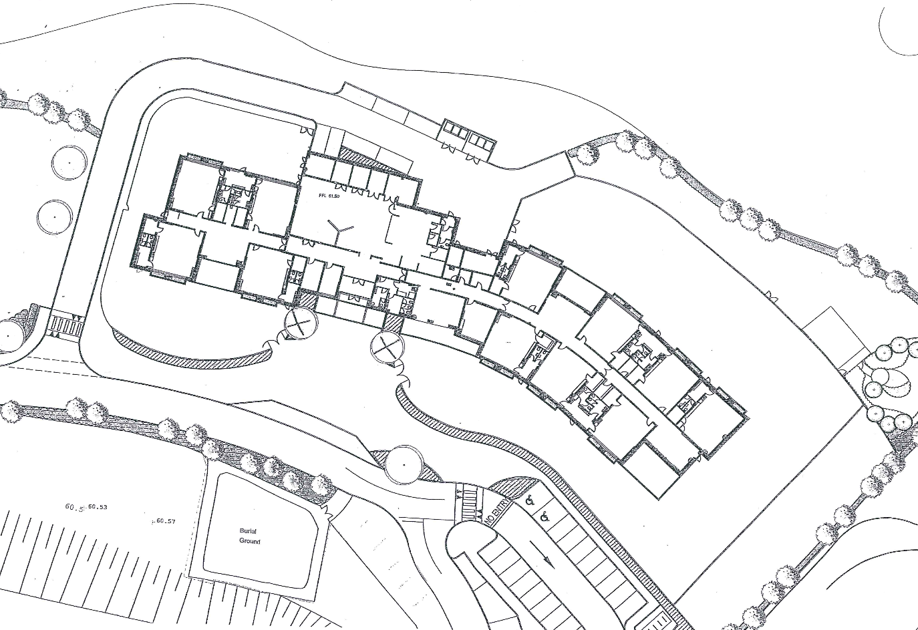**Entrance Gate**

E

D

C

B

A

Pupils should enter through the following gates:

**Gate A:** Yr1 CT/EMcG

**Gate B:** Yr1 AC & Yr2LQ

**Gate C:** Breakfast Club & Yr2CS

**Gate D:** All other classes

**Gate E:** There will be no entry for pupils or adults during the school day (8.15am-3.00pm). This gate will be padlocked shut.

**Staggered Pick Ups**



**Parents are asked to park at front of school, pavements must be kept clear around the whole school as children will be leaving from multiple exit points.** Please collectFoundation Stage child(ren) first then Key Stage 1/2 children. **Once you have collected your child(ren) you must leave the school site as quickly as possible to ease congestion.**

For the staggered pickups to work it is important that parents **do not arrive before their allocated pick up time**. I would greatly appreciate your co-operation with this and ask you to be patient and respectful to each other and school staff as we work together to get your children home safely.

|  |  |
| --- | --- |
| Pick Up | |
| 2.00pm | Yrs 1&2 (and older siblings) |
| 2.20pm | Yrs 3&4 (and older siblings) |
| 2.40pm | Yrs 5&6 (and older siblings) |
| 3.00pm | Yr 7 |

Parents/Guardians are to line up at the following designated gates and wait to collect their children:

Gate A: Yr1 CT/EMcG (line up in direction of red arrow)

Gate B: Yr1 AC (line up in direction of orange arrow)

Gate B: Yr2LQ (line up in direction of brown arrow)

Gate C: Yr2CS (line up in direction of green arrow)

Gate D: All other classes (line up in direction of blue arrow)

Gate E: No exit for staff or pupils

Yours sincerely

H. Walls