St. Colmcille’s Primary School

New School Day
Parent Guide

August 2020

Version 1.0

New School Day
We all have a responsibility to provide the safest environment possible for our children and school community as the Education Restart programme begins. This guidance is a compilation of the procedures that have been outlined in parent letters over the summer months. The following steps must be consistently followed to ensure the safety of all our school family.

Pupil Attendance
Pupils who are extremely clinically vulnerable and have been advised to stringently follow social distancing guidelines should learn from home where possible.
Pupils who live with someone who is clinically vulnerable can attend school.

Covid-19 Symptoms
Pupils who exhibit any symptoms associated with Covid-19 should not attend school.
- If your child has symptoms of the coronavirus or a positive test, they will need to stay at home for at least 10 days. It is important that you inform the school if anyone within your household has had a positive test.
- If someone within your household has symptoms or a positive test, they will need to stay at home for 14 days from the day the first person in the home started having symptoms.
- However, if they develop symptoms during this 14 day period, they will need to self-check in accordance with Test and Trace guidance and stay at home for 10 days from the day their symptoms started (regardless of what day you are on in the original 14-day period).
- 10 days after their symptoms started, if they do not have a high temperature, they do not need to continue to self-isolate. If they still have a high temperature, they must keep self-isolating until their temperature returns to normal.

- Staff or pupils who have been part of the same ‘bubble’ as anyone who has tested positive, must likewise follow PHA guidance and self-isolate and undertake a test under the Test and Trace and Protect system.

People Who Become Symptomatic Onsite
- If anyone becomes unwell with a new, continuous cough or a high temperature/fever or anosmia (loss/change in normal sense of smell or taste) they and any members of their household within the school will be sent home and advised to follow PHA guidance.
- A child(ren) awaiting collection will be moved to the Multi-Purpose Room and isolated.
- PPE will be worn by staff caring for the child if direct personal care is needed and a distance of 2m cannot be maintained.
- All affected areas will be cleaned and disinfected once the person with symptoms has left.
- If a bubble needs to leave their classroom for cleaning to take place, they will go to the Assembly Hall.

Staggered Drop Off
- Each family are only required to use one drop off time.
- Only one parent/guardian should drop the child off at school.
- Children are to go straight to their classroom on arrival.
- Parents are not permitted to enter the classrooms/playground.
- Parents must not congregate at the school gates/car park. Please leave the school site as quickly as possible to ensure traffic remains free flowing.
- Children must wash their hands on/before entering the classroom.
- Children will participate in supervised activities until class starts.
- Year 2-7 classes will start at 8.55am and Year 1 will start at 9.15am.

Drop Off Timetable
Drop Off
8.15am | Yrs 6&7 (and younger siblings)
8.30am | Yrs 4&5 (and younger siblings)
8.45am | Yrs 2&3 (and younger siblings)
9.00am | Yr 1

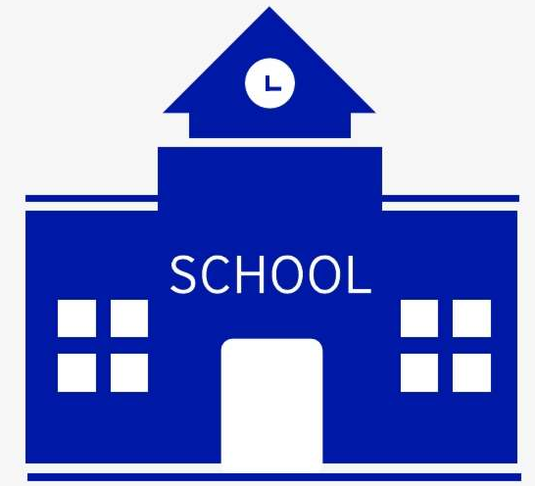
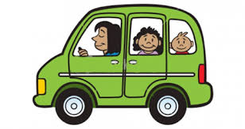
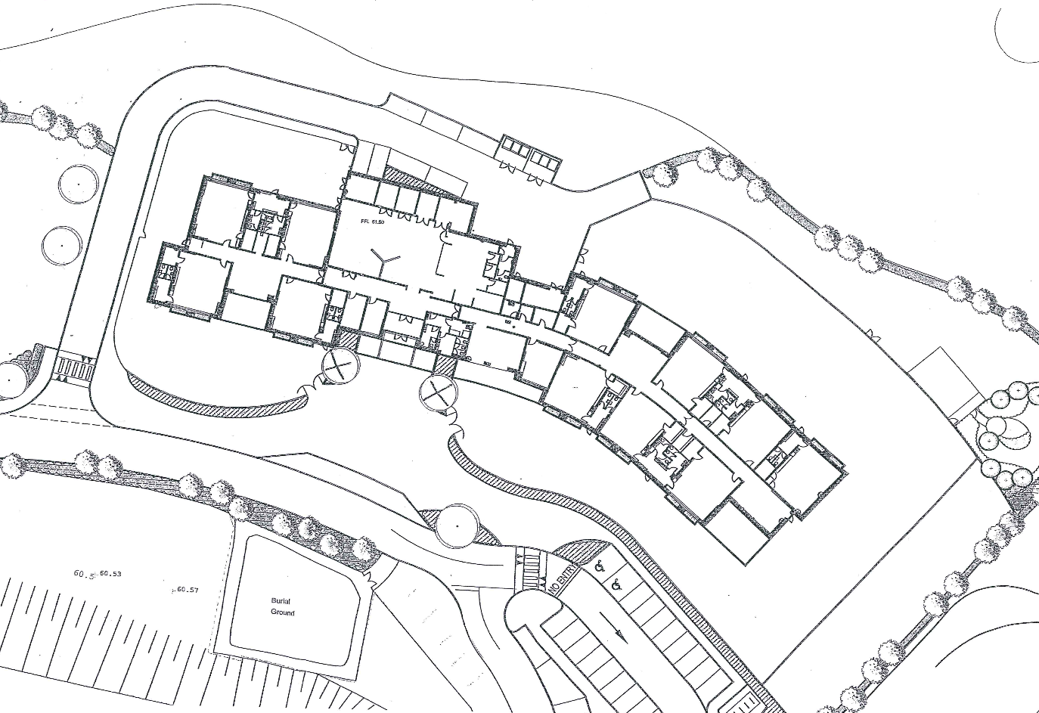
Entrance Gates
E
D
C
B
A

Pupils should enter through the following gates:
Gate A: Yr1 CT/EMcG
Gate B: Yr1 AC & Yr2LQ
Gate C: Breakfast Club & Yr2CS
Gate D: All other classes
Gate E: There will be no entry for pupils or adults during the school day (8.15am-3.30pm). This gate will be padlocked shut.
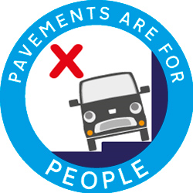
- Please do not park in the turning corner or the area around Gate E. If there are no parking spaces left around the back, please park in front car park.
- Please do not obstruct any pavements when parking.
- Pupils are not permitted to enter through the main front doors.

After School Pick ups
- Gate E will be open for collection of children from the After-School Club from 3.30pm onwards.

Access to the building
- The front door will remain locked throughout the day to control the flow of visitors.
- School visitors will be kept to a minimum- focus on Special Educational Needs and Health and Wellbeing.
- Parents will be allowed to access the School Office one at a time.
- All visitors must wear a face mask entering the building unless medically exempt.
- Communication with teaching staff will be via phone and email.

School Transport
- Home to school transport should only be used when there is no alternative available.
- The ‘Country’ bus will run as normal. The Department of Education have lifted the requirement for stringent social distancing to be followed on dedicated home to school transport vehicles.
- Children on the Country bus must sit with their siblings and/or children from the same protective bubbles were possible.
- It is strongly recommended that all pupils wear a face covering on all school transport including buses and taxis.
- Pupils are to go straight to class after alighting from the bus, take off their face masks and wash their hands before taking their seat.
- It is the pupil’s responsibility to store their face mask during the school day. These must not be brought into the classroom.
- There will be no Ulsterbus service in the morning or afternoon until further notice.
- Car sharing with children of other households should be avoided.

Social Distancing- Adults
- Public Health guidance with respect to social distancing of 2 metres will remain in place between adults when on the school site.
- Parents should always remain a minimum of two metres apart from each other.
- Parents must also adhere to social distancing when in contact with all school staff.

Social Distancing- Pupils
Foundation Stage
- There will be no social distancing in the Foundation Stage. Children of this age will not be able to adhere to social distancing between themselves or adults.
- The classroom has been set up with control measures to encourage space between the children where possible.
These may include:
- specific easy to clean toys put out on rotation
- children given “base places”- designated seats to sit in.
- removal of soft furnishings and close contact areas (home corner/reading corner).
- individual sets of resources for each child.
- Trays set up around classroom for snack pots, water bottles, lunches.
- Allocation of resources to the same class rather than sharing across classes.
Key Stage 1 &2
- Social distancing within classes will be maximised based on physical capacity.
- Classroom control measures have been set up to encourage space between the children where possible.
These may include:
- ensuring that pupils do not congregate in communal areas such as cloakrooms and toilets.
- tables spaced out, with children sitting in twos facing forwards.
- designated seats within class, no moving for maths/literacy or lunch.
- resources from around classroom removed, surfaces included teacher’s table kept clear.
- resource trays/boxes set up for each child.

Protective Bubbles
- Pupils will be grouped by class and these groups will remain consistent.
- Adults assigned to that class will form part of the bubble also.
- Communal areas- computer suite, resource areas, assembly hall will not to be used.
- Pupils will not use the central corridor; external doors will be used.
- Sharing of resources between separate bubbles will be kept to a minimum.

School Uniform
- Children are expected to wear full school uniform apart from school ties for the boys
- Children can wear a plain navy jumper and white polo t-shirt on days when uniform is being washed.
- Children must wear black school shoes- black trainers are not acceptable.
- All children are expected to bring in a pair of plimsolls/change of shoes which will be kept in school.
- Children should bring a coat with them to school every day.
- It is recommended that children wear a fresh set of uniform each day.
Equipment
Children can bring their school bag to school. This must be kept in the cloakroom. The following items are permitted
- filled water bottle
- coat- we will be going outside except for in the most extreme conditions.
- Packed Lunch and Healthy Snack
Children SHOULD NOT bring
- pencil cases
- PE kits
- toys
- PPE

All uniform and personal possessions should be clearly labelled with child’s full name and class.
Break Time
- Children should bring a healthy snack (fruit, veg or bread) with them each day.
- There will be no break from the canteen or school milk until further notice.
- Children are to wash their hands before eating their break.
- Children are to eat their snack before going outside for play.
- Children must remain with their own bubble throughout break time.
- There will be no facility to ‘keep children in’ at break. If a child is in school, they will be taken outside with their classmates.
- Pupils are not permitted to use another class’ toilets during break.
- The Trim Trails will not be used by class bubbles at present.

Playground Zones
The school playgrounds have been split into 5 zones and each will only be used by one class bubble at a time.
5
4
3
2
1
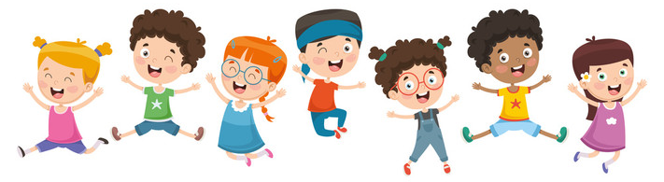
School Meals
- School Meals will be available from 1st September 2020. These will be packed lunches until further notice and will be delivered to the classrooms by canteen staff.
- Year 1 pupils who are Free School Meals will take their packed lunch home with them until Friday 25th September.
- Children are to stay in their designated seat to eat their lunch.
- Children need to wash their hands before eating.
- Children can bring their lunch to school in disposable wrapping or a washable/wipeable lunch box.
- No food is to be taken outside.
- Teachers will remain with their class whilst they eat their lunch.

Hygiene
- Adults and Children are to wash their hands on arrival at school.
- Children should be shown how to wash their hands properly- for at least 20 seconds.
- Hand washing will be repeated regularly throughout the school day- after using toilet, before eating, after coming in from break and lunch, before leaving for home and at the teacher’s/classroom assistant’s discretion thereafter.
- Hand sanitiser is available in each classroom to supplement hand washing.

- Respiratory Hygiene: use of the ‘catch it, bin it, kill it’ approach should be discussed with and explained to your child. Children should have a pocket pack of tissues with them each day.
- Children should be discouraged from touching their eyes, face, nose and mouth.
- Children should be shown how to cough into a tissue and how to dispose of it appropriately. They then should wash their hands thoroughly.
- Children should be shown how to cough into their elbow.

- Doors and windows will be kept open to increase natural ventilation and to reduce contact with door handles.

Use of non-contact thermometers
- Each staff member and child’s temperature will be checked each morning before their playground time.
- If anyone has a high temperature, the Senior Leadership Team will be notified, and the following steps may be implemented:
- Isolate and send person home.
- Isolate and recheck temperature after an agreed interval.

Toilets
- Each class bubble has been allocated their own toilets to use.
- Only one child will be allowed to use the toilet at a time.
- All children MUST follow handwashing procedure after using the toilet.
- Additional signage has been placed in the toilets to remind children of hand washing routine.
- Additional cleaning staff will conduct toilet checks and cleaning during the school day as well as the regular daily clean.

Cleaning
- Unnecessary items from classrooms have been removed.
- Surfaces will be kept clear for ease of cleaning.
- Pupil workstations will be wiped down and disinfected after use.
- Regular cleaning of door handles, desktops and frequently touched surfaces will take place during the day.
- Any small hands on items that children have used each day will be disinfected and then put somewhere to dry. Resources will be used on rotation to allow for this.

Pupil Behaviour
- Refusal to adhere to arrangements of social distancing and/or deliberately coughing or spitting at pupils/adults putting them at risk are deemed as examples of Serious Level Misbehaviour.
- The Range of Consequence for serious level misbehaviour will therefore be applied.
- See Appendix 1 for amended Positive Behaviour Policy.

Curriculum Delivery
- Focus in Term 1a will be on Literacy, Numeracy and PDMU.
- ICT will take place within the classroom, PCs and Ipads have been assigned to each bubble and these will not be shared between bubbles. PCs and Ipads will be cleaned after each use.
- Children will have regular access to PE- more details to follow.
- There will be increased opportunities for purposeful outdoor activity/learning.

Feedback and Marking
- Children will mark their own work when possible (Key Stage 2).
- Children are to leave exercise books open on their desk, teacher/LSA to wash hands, collect books and take to marking station.
- No exercise books will be taken out of classroom.

Staggered Pick Ups
E
D
C
A
B
- Each family are only required to use one pick up time.
- Parents are asked to park at front of school, pavements must be kept clear around the whole school as children will be leaving from multiple exit points.
- Parents to collect FS child(ren) first then KS1/2 children.
- KS1/2 children will be supervised in class bubbles under the canopy (yellow area on map) for collection.
- Parents are not permitted to enter the classrooms/playground.
- Parents must adhere to social distancing guidance and line up in an orderly fashion.
- Once you have collected your child(ren) you must leave the school site as quickly as possible to ease congestion.
- Please do not arrive before your allocated pick up time as this will cause a build up in traffic, which defeats the purpose of staggering the pick up.
Pick Up
2.00pm | Yrs 1*&2 (and older siblings)
2.20pm | Yrs 3&4 (and older siblings)
2.40pm | Yrs 5&6 (and older siblings)
3.00pm | Yr 7

*Year 1 pick-up time is 12noon until Monday 28th September 2020.
Parents are to line up at the following designated gates and wait to collect their children:
Gate A: Yr1 CT/EMcG (line up in direction of red arrow)
Gate B: Yr1 AC (line up in direction of orange arrow)
Gate B: Yr2LQ (line up in direction of brown arrow)
Gate C: Yr2CS (line up in direction of green arrow)
Gate D: All other classes (line up in direction of blue arrow)
Gate E: No exit for staff or pupils
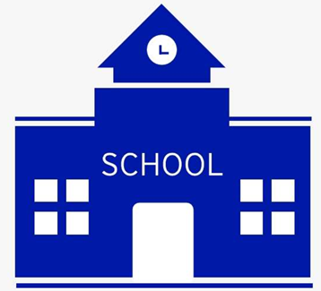
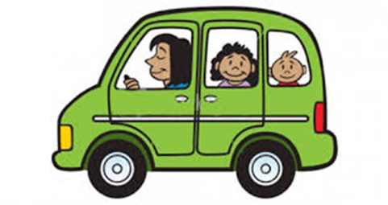

Childcare Provision- St. Colmcille’s After School Club
- Breakfast Club will run each morning from 7.45am-8.45am
- Breakfast Club will take place in the Assembly Hall and pupils must enter via Gate C.
- At the end of Breakfast Club children will be escorted to their classrooms by the Play Leaders.

- There will be no Late Room between 2.00pm-3.00pm until further notice.

- After School Club will run from 2.00pm-6.00pm. 2.00pm-3.00pm in the Assembly Hall and from 3.00pm in the After School double mobile.

- Gate E will be opened from 3.30pm to allow parents to collect their children from After School Club.

Appendix 1
Making Consequences appropriate to Misbehaviour

Examples of  Low Level Misbehaviour | Range of Consequences
Talking out of turn  Shouting out  Leaving seat at the wrong time  Not doing homework  Not listening  Not paying attention  Distracting others  Making noises  Failing to keep on task  Leaving work area untidy  Pushing in the line  Running in the corridors | Verbal warning  Moving seat  Clean up mess  Complete homework the following night
Examples of  Moderate Level Misbehaviour | Range of Consequences
Persistently talking out of turn  Persistently shouting out  Persistently leaving seat at the wrong time  Persistently not doing homework  Persistently not listening  Persistently not paying attention  Persistently distracting others  Persistently making noises  Persistently failing to keep on task  Persistently leaving work area untidy  Hitting / pushing / fighting  Refusal to co-operate | Shadowing staff in playground  Time out at play-time  Step 1: Sent to a teacher within the year group – record action in behaviour report record (Appendix B).  Step 2: On being sent to the year group teacher for a 2nd time the parent is contacted and made aware both the reason for this action and subsequent actions.  Step 3: Sent to a member of the Leadership Team and the parent is invited to a meeting with class teacher and Senior teacher.  Daily Behaviour Report initiated  Consider putting child on the SEN Register for behavioural problems  Record action in the class and central behaviour report record
Examples of  Serious Level Misbehaviour | Range of Consequences
Disregarding adults within the school  Stealing  Physically/emotionally hurting someone  Serious physical/verbal threat made to staff  Displaying violence  Leaving school without permission  Refusal to adhere to arrangements of social distancing.  Deliberately coughing or spitting at pupils/adults putting them at risk. | Sent to the leader of Pastoral Care / Principal  Parents are invited to a meeting  Consider referral to Educational Psychologist  Consider suspension/expulsion  Record action in central behaviour report record

